
ALAMO
HEIGHTS
HIGH
SCHOOL
UIL
Eligibility
Information
UIL
GRADE
CHECKS
:
A
student
shall
be
suspended
from
participation
in
any
extracurricular
activity sponsored or sanctioned by the District or the UIL after a grade evaluation period in which the student received a grade lower than a 70 in any class other than Exempt Courses. Students may regain eligibility if they are passing all classes on their next progress report.
EXEMPT COURSES LIST: Dual Credit English III/IV, Dual Credit Teach Program, Pre-calculus (grade level and advanced), On Ramps Physics, AP courses (listed below)
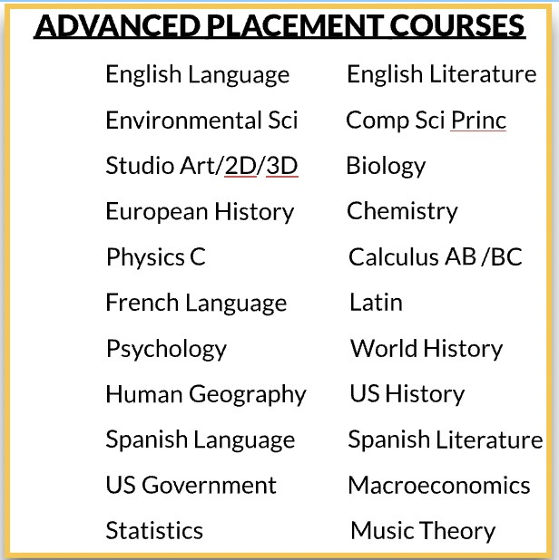
RESOURCES:
UIL Eligibilty Calendar
UIL Eligibilty Standards
CONTACT INFORMATION:
Athletics- Jennifer Fox, Assistant Athletic Director, jfox@ahisd.net
Fine Arts- David Stephenson, Fine Arts Coordinator, dstephenson@ahisd.net
UIL Academics/Clubs- Contact Club Sponsor(s)
Last Date Revised: September 28, 2022

